
INTERNATIONAL CYBERSECURITY AND DIGITAL FORENSICS ACADEMY

ASSIGNMENT

Assignment Title: OWASP JUICE PENETRATION TESTING

Student Name: Ahmad Zubairu Garba
Student ID: 2025/FWSD/11463
Course: Web Application Penetration Testing Methodologies
Course Code: BVWS105
Instructor: Aminu Idris

9/APRIL/2026
SECTION 1: Reconnaissance & Application Mapping
I explored the site manually to find every place where a user can enter text or interact with the database.
Page | Input Field | Possible Use | Link
Landing Page | Search Bar | Test for XSS or SQLi | https://juice-shop.herokuapp.com/#/search
Login | Email & Password | Auth bypass / SQLi | https://juice-shop.herokuapp.com/#/login
Registration | Email, Password, Security Q | Database injection | https://juice-shop.herokuapp.com/#/register
Contact Us | Comment, Rating, Captcha | Stored XSS / Logic flaw | https://juice-shop.herokuapp.com/#/contact
User Profile | Username, Image upload | File upload vulnerability | https://juice-shop.herokuapp.com/#/profile
Basket | Product Quantity | Parameter tampering | https://juice-shop.herokuapp.com/#/basket
Password Reset | Security Answer | Broken Authentication | https://juice-shop.herokuapp.com/#/forgot-password
FTP Directory | File list | Info Disclosure | https://juice-shop.herokuapp.com/ftp

SECTION 2: Vulnerability Identification (OWASP-Based Thinking)
Based on my initial reconnaissance, I identified the following potential weaknesses.
Vulnerability | Location (Link) | Possible Impact | Remediation
SQL Injection | https://juice-shop.herokuapp.com/#/login | Login bypass & data theft | Use Parameterized Queries
Reflected XSS | https://juice-shop.herokuapp.com/#/search | Script execution in browser | Output encoding
IDOR | https://juice-shop.herokuapp.com/#/basket | View other users' carts | Server-side ID validation
Security Misconfig | https://juice-shop.herokuapp.com/ftp | Sensitive file leakage | Restrict directory access
Broken Auth | https://juice-shop.herokuapp.com/#/forgot-password | Account Takeover | Use strong MFA
SECTION 3: Practical Testing & Exploitation Narrative
Test 1: Authentication Bypass via SQL Injection
To test the robustness of the authentication module, I targeted the login endpoint at http://localhost:3000/#/login. By inputting a classic tautology payload—' OR 1=1 -- into the email field and providing a dummy password, I attempted to manipulate the back-end SQL query logic. The application failed to sanitize this input, causing the database to evaluate the statement as true for the first record in the table. Consequently, I was granted immediate access to the administrative account without providing a valid credential.
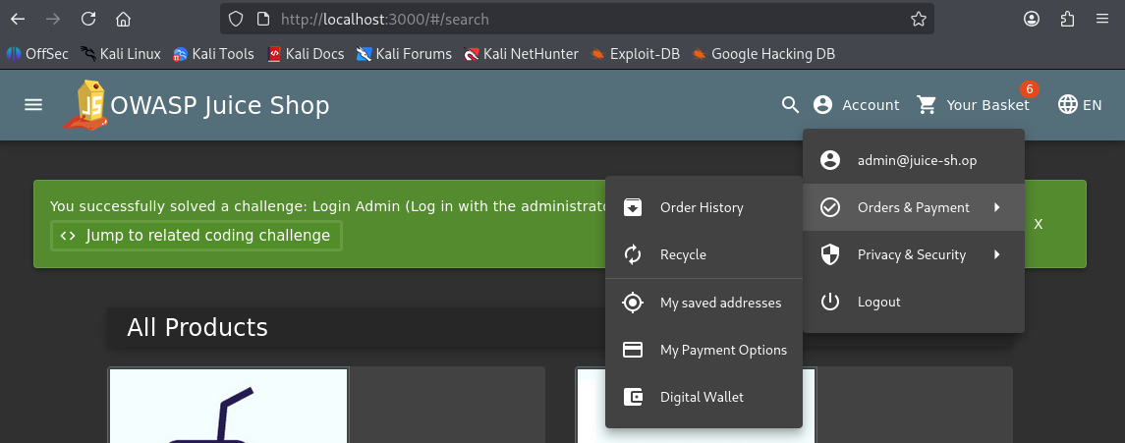
Test 2: Cross-Site Scripting (XSS) in Search Functionality
I conducted a reflected XSS test by injecting a JavaScript payload into the search bar located at http://localhost:3000/#/search. I utilized the payload <iframe src=" javascript:alert('XSS_Test Ahmed')"> to verify if the application would execute arbitrary scripts within the client’s browser environment. The application rendered the input directly into the Document Object Model (DOM) without proper output encoding, triggering the alert box. This confirmed that the endpoint could be leveraged to execute malicious scripts, such as those used for session hijacking.
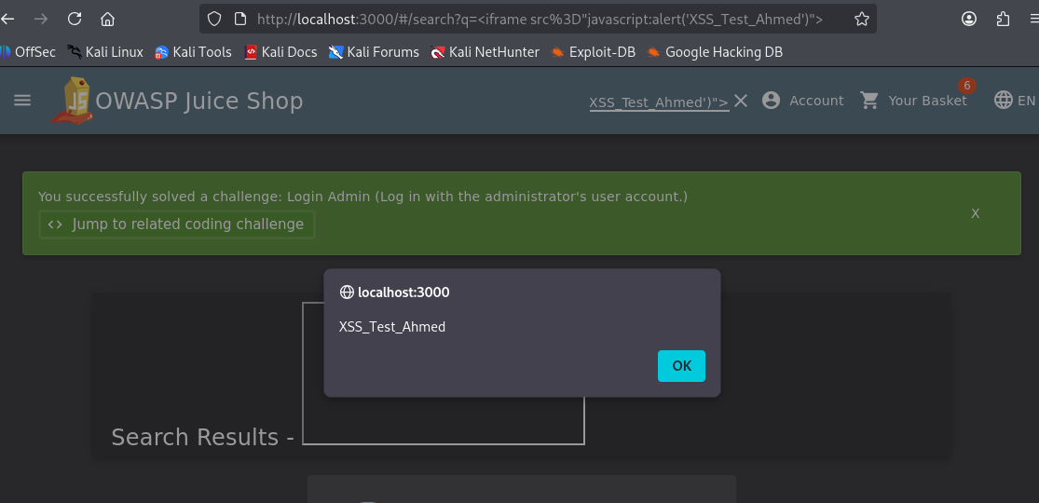
Test 3: Horizontal Privilege Escalation (Broken Access Control)
After establishing an administrative session through the initial SQL injection, I tested for unprotected internal routes. I manually modified the URL to target the http://localhost:3000/#/administration endpoint. Because the application relied on client-side "hiding" of UI elements rather than robust server-side authorization checks, the dashboard loaded successfully. This granted me full visibility into the registered user base and administrative metadata, proving that the route is not properly restricted to authorized personnel.
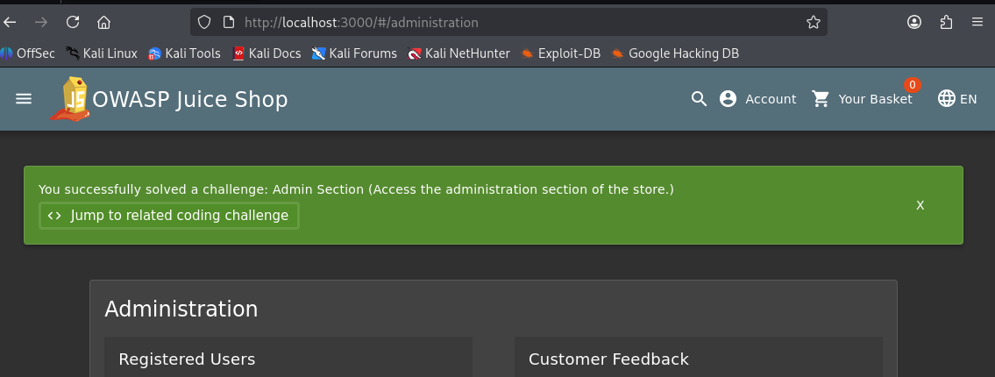

Test 4: Directory Traversal and Information Disclosure
During the reconnaissance phase, I identified an unprotected directory at https://juice-shop.herokuapp.com/ftp. I attempted to access this path directly to check for sensitive assets stored on the server. The server returned a full directory listing, exposing several backup and configuration files, including coupons_2013.md.bak. I was able to download and view these files, demonstrating that the application is leaking internal data which could be used to facilitate more complex, multi-stage attacks.
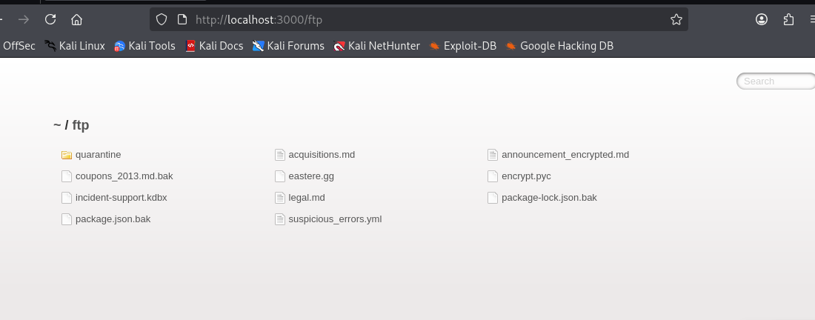

Test 5: Business Logic Flaw in Basket Management
I investigated the shopping basket at https://juice-shop.herokuapp.com/#/basket to determine if client-side inputs were strictly validated before being processed. I added a single item to the cart and then attempted to modify the quantity to a negative integer (e.g., -10) by manipulating the request parameters. The system accepted the negative value without an error, which negatively altered the total price calculation. This logic flaw indicates that a malicious user could potentially manipulate the checkout process to bypass payment requirements.
SECTION 4: Findings & Risk Analysis
I compared my results to the OWASP Top 10. The most critical finding is A03:2021-Injection, as it allows full control over the admin account. A01:2021-Broken Access Control is also a major concern since the administration page is only "hidden" but not properly locked down.
ID | Vulnerability Name | Severity | Status | Mitigation Strategy
V01 | SQL Injection (SQLi) | Critical | Confirmed | Implement parameterized queries/prepared statements for all database interactions.
V02 | Reflected XSS | High | Confirmed | Apply context-aware output encoding and implement a strict Content Security Policy (CSP).
V03 | Broken Access Control | High | Confirmed | Enforce server-side authorization checks for all administrative routes and API endpoints.
V04 | Sensitive Data Exposure | Medium | Confirmed | Disable directory listing on the web server and restrict access to the /ftp directory.
V05 | Business Logic Flaw | Medium | Confirmed | Implement server-side validation to ensure quantity inputs are positive integers before processing.

SECTION 5: REPORTING
Part A: Executive Summary
To: Board of Directors
Subject: High-Level Security Risk Assessment – OWASP Juice Shop
Overview of Testing A comprehensive security assessment was conducted on the OWASP Juice Shop web application to evaluate its resilience against modern cyber threats. The testing focused on identifying vulnerabilities that could lead to unauthorized access, data theft, or financial manipulation.
Key Risks Identified The assessment uncovered several critical security gaps. Most notably, the application’s "front door" (login) is susceptible to bypass techniques, and internal administrative dashboards are accessible to unauthorized users. Furthermore, customer data and internal server files were found to be improperly protected and visible to the public.
Business Impact These vulnerabilities pose a significant risk to the organization:
- Data Breach: Sensitive customer information could be stolen, leading to legal penalties and loss of consumer trust.
- Reputational Damage: Successful exploitation of these flaws could be publicized, severely damaging the brand’s image.
- Financial Loss: Business logic flaws allow for the manipulation of transaction totals, directly impacting revenue.
Immediate investment in remediation and secure coding training is required to bring the application up to industry safety standards.
Part B: Technical Report
To: IT & Security Engineering Team
Subject: Technical Vulnerability Deep-Dive and Remediation
1. Vulnerability: SQL Injection (SQLi)
- Mechanism: The application’s authentication module fails to sanitize the email input field before passing it to the back-end database query. This allows for "Tautology" attacks where a logical TRUE statement is injected to bypass password verification.
- Reproduction Steps: 1. Navigate to the /login endpoint.
2. Inject ' OR 1=1 -- into the email field.
3. Provide any string for the password and submit.
- Recommendation: Implement Parameterized Queries (Prepared Statements). Ensure that the database driver handles user input as a literal value rather than part of the executable SQL command.
2. Vulnerability: Reflected Cross-Site Scripting (XSS)
- Mechanism: The q parameter in the search function is rendered directly back to the page without context-aware output encoding. An attacker can inject malicious JavaScript that executes in the context of the user’s session.
- Reproduction Steps:
  - Append <iframe src="javascript:alert('XSS')"> to the search query.
  - Observe the browser executing the script via a pop-up alert.
- Recommendation: Apply Output Encoding (e.g., HTML Entity encoding) on all reflected user inputs. Implement a Content Security Policy (CSP) to restrict script execution to trusted sources.
3. Vulnerability: Insecure Direct Object Reference (IDOR) / Access Control
- Mechanism: The application relies on client-side routing logic to restrict access to the /administration panel. It lacks server-side session validation to confirm if the requesting user holds administrative privileges.
- Reproduction Steps:
  - Authenticate as a standard user.
  - Manually navigate to http://[host]/#/administration.
- Recommendation: Enforce Server-Side RBAC (Role-Based Access Control). Every request to sensitive endpoints must be verified against the user's session token on the server before data is returned.

